Checking in to VMU-1

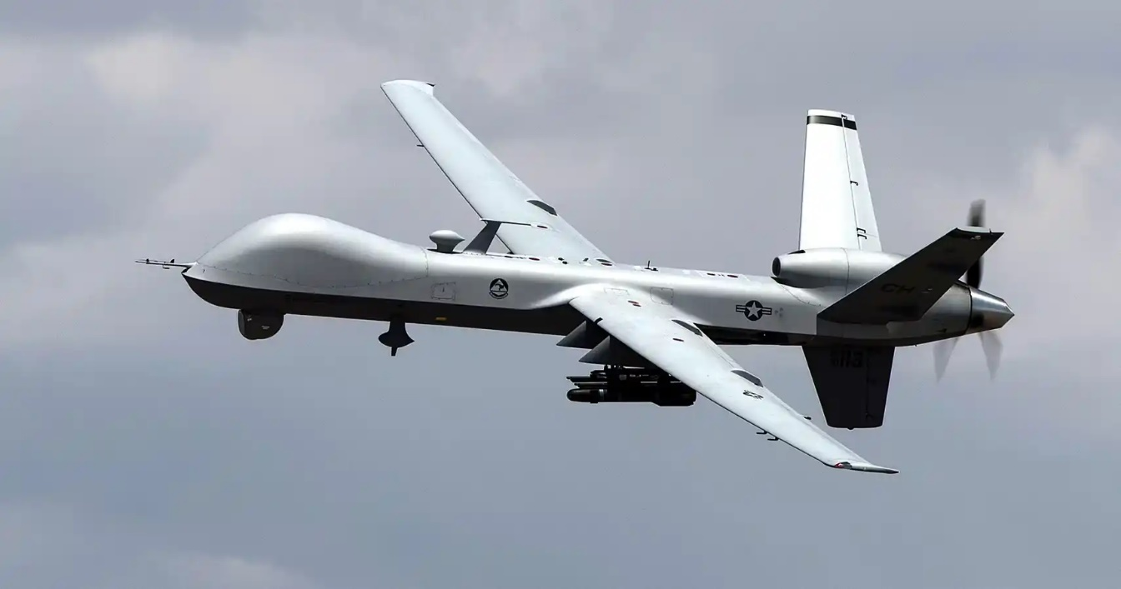

Checking In

Business hours: Monday through Friday, 0800-1630: Building 408.

To check in, please coordinate with the VMU-1 Adjutant, 2ndLt Robertson, and/or your sponsor from your department to find building 408 and come to the S-1. You will need an escort to enter building 408.

Adjutant comm: 928-269-0071.

Weekends, after hours, and Holidays:

If you must check in after hours, please contact the Squadron Duty Officer (SDO). If the Squadron Duty Officer is unavailable, please contact the Marine Aircraft Group 13 Duty Officer (GDO) or Group Duty Clerk (GDC) for help checking in.

SDO comm: 928-247-0728

GDO comm: 928-269-2124

GDC comm: 928-269-3386

Building 408 is located on the corner of Halstead and Aldrich streets. You can park under the covered parking to the south of the building or the lot behind the softball field to the east of the building, so long as the spot is unmarked. The adjutant or the SDO can provide more in depth instructions if necessary.